**jQuery Activity**

1. Describe how to use JQuery event methods. Describe the two common JQuery event methods explained in the following page and do the exercises.  http://www.w3schools.com/jquery/jquery_events.asp

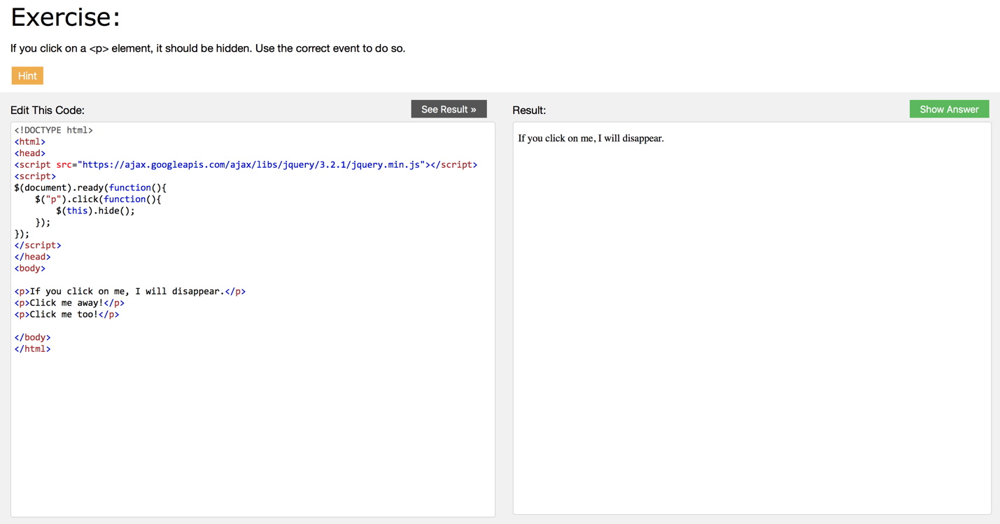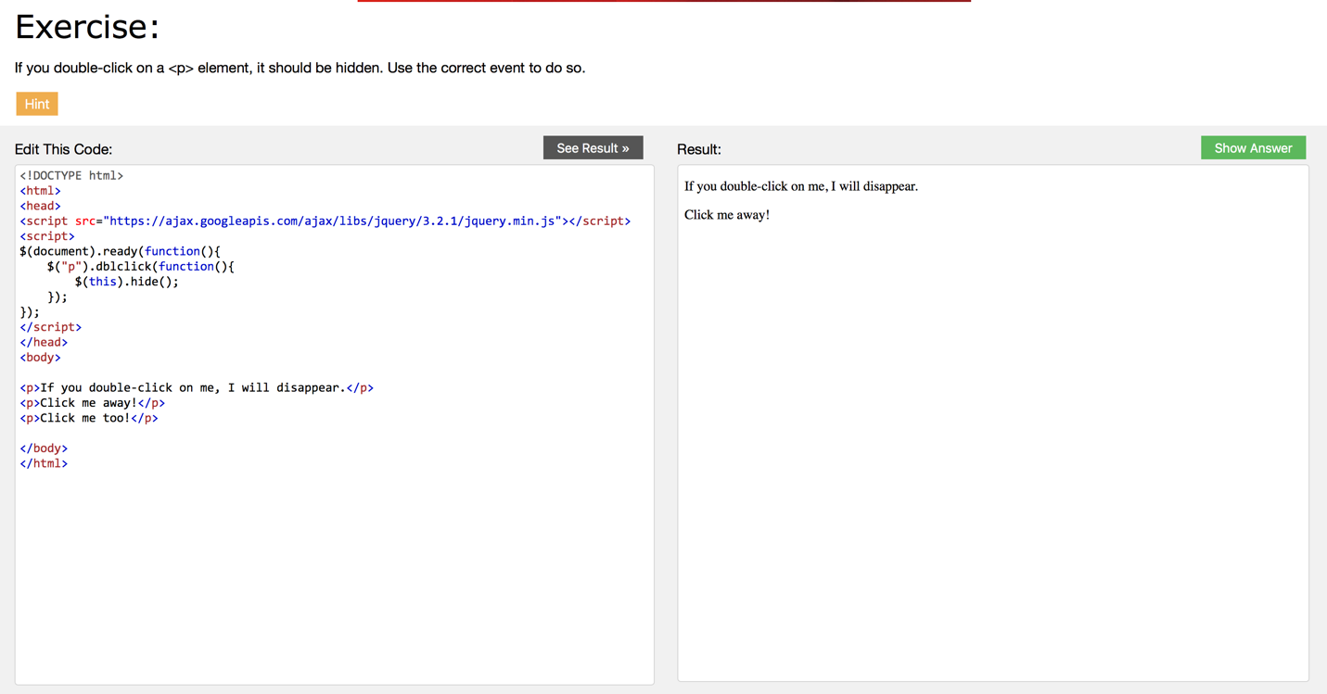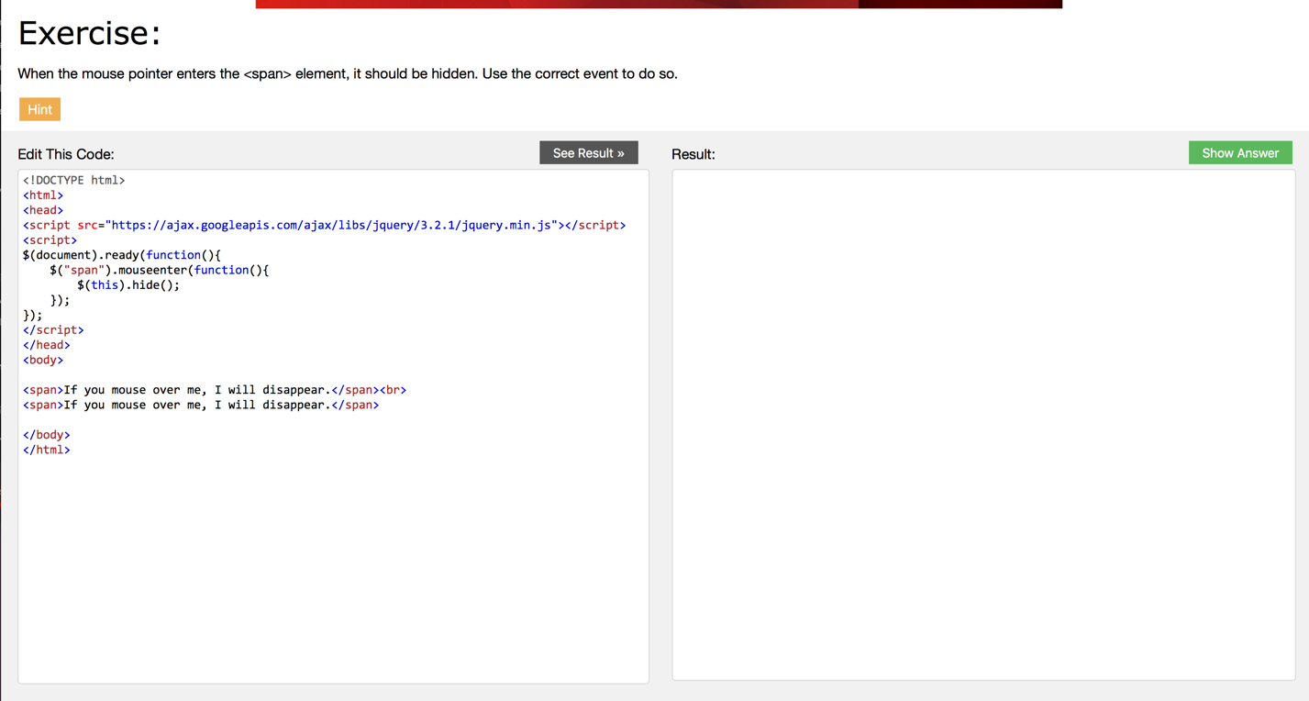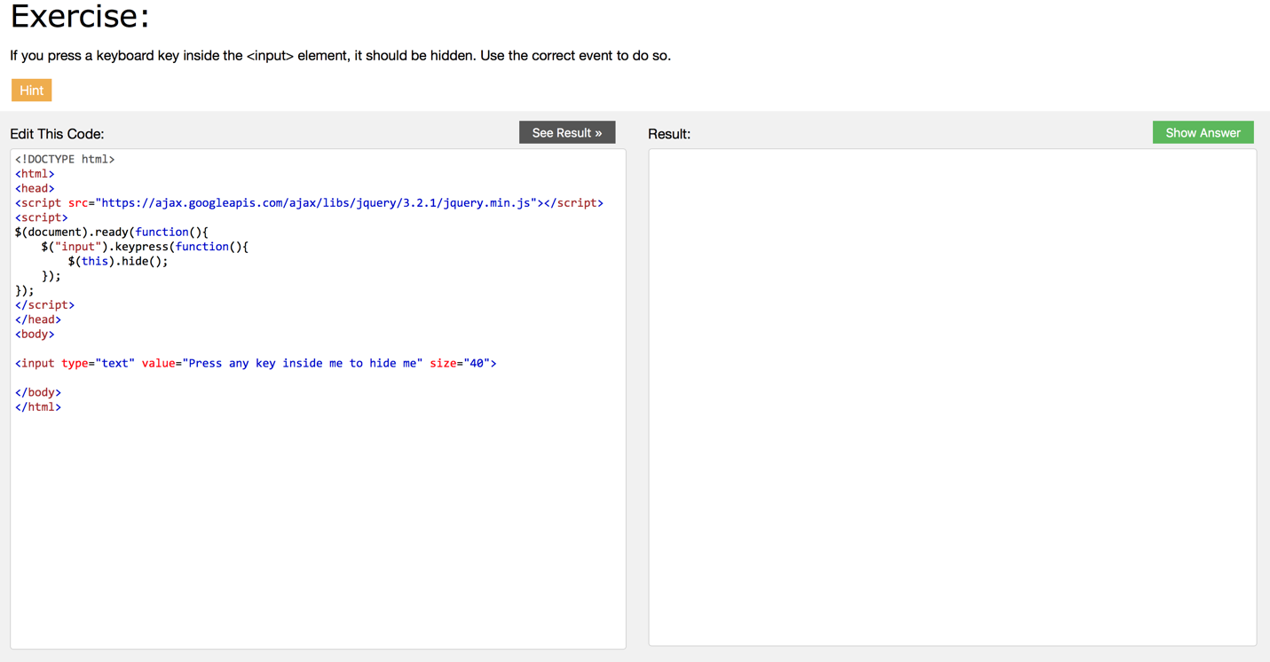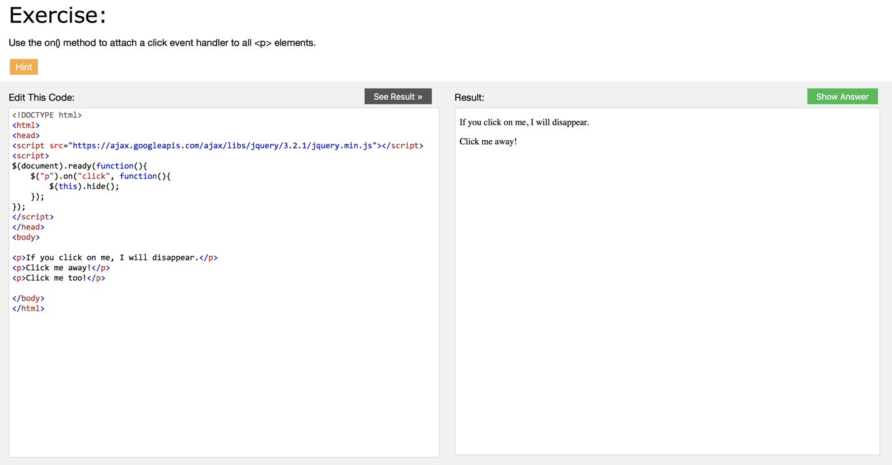

1. Describe how to change css style properties of selected elements using JQuery and do the exercises in http://www.w3schools.com/jquery/jquery_css.asp

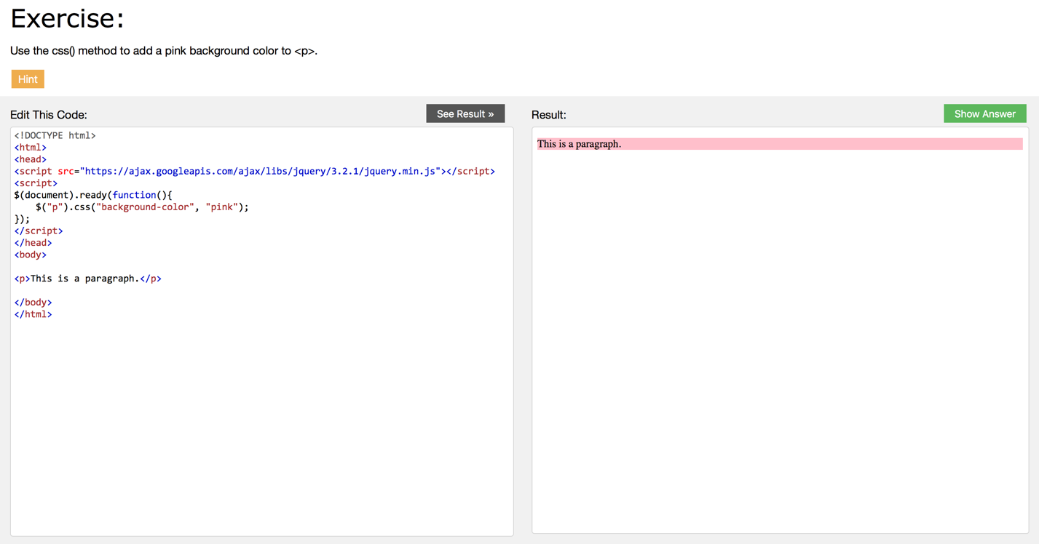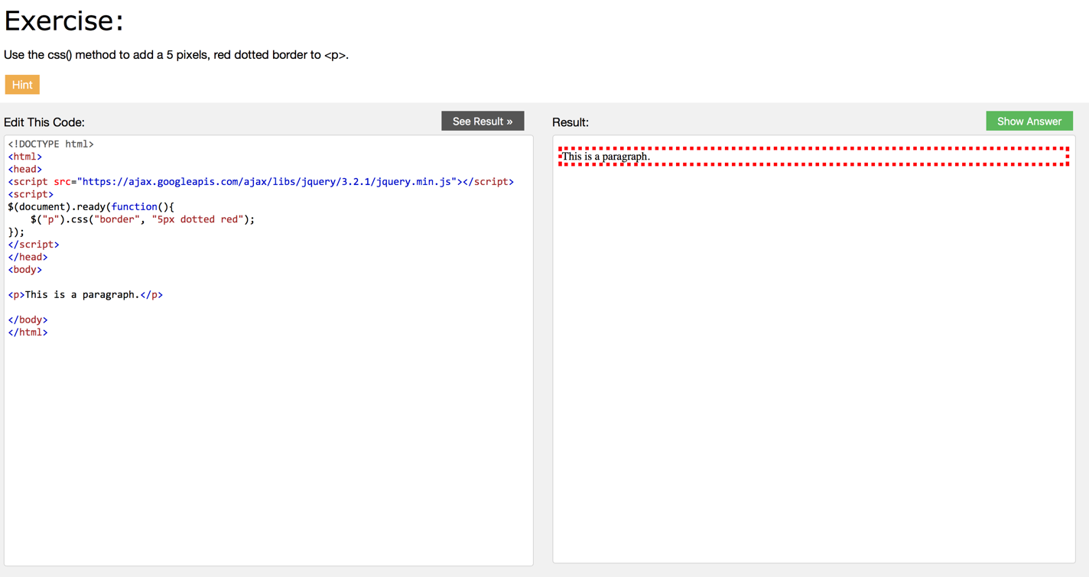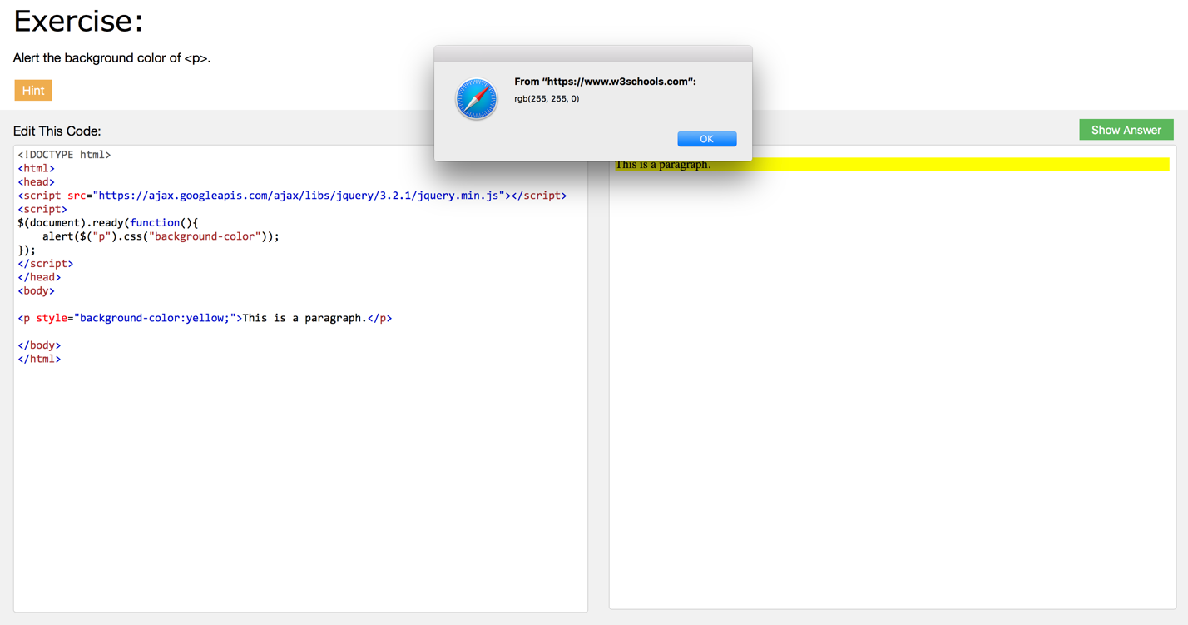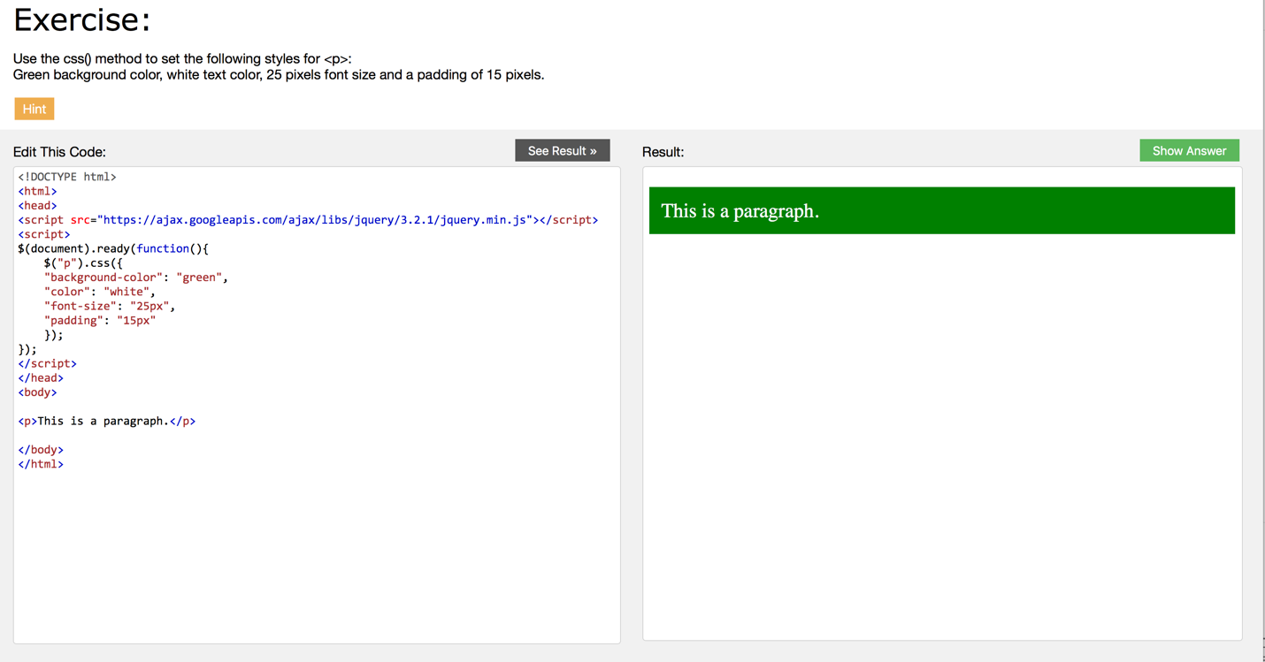

1. c) Describe how to read and set values in a text box using JQuery.

The val() method returns or sets the value attribute of the selected elements.

Return the value attribute: $(selector).val()

Set the value attribute: $(selector).val(value)

Set the value attribute using a function: $(selector).val(function(index, currentvalue))

*3) Describe what is JQuery UI - Go to the page and check demos.*

jQuery library is a User Interface Library that provides the advantage of creating a dry code and it includes themes, effects, widgets and mouse interactions.

It also provides plugins for data validation and drop down menus.